Project Design Phase-II

Technology Stack (Architecture & Stack)

|  |  |
| --- | --- |
| Date | 15 October 2022 |
| Team ID | PNT2022TMID51155 |
| Project Name | Smart Fashion Recommender Application |
| Maximum Marks | 4 Marks |

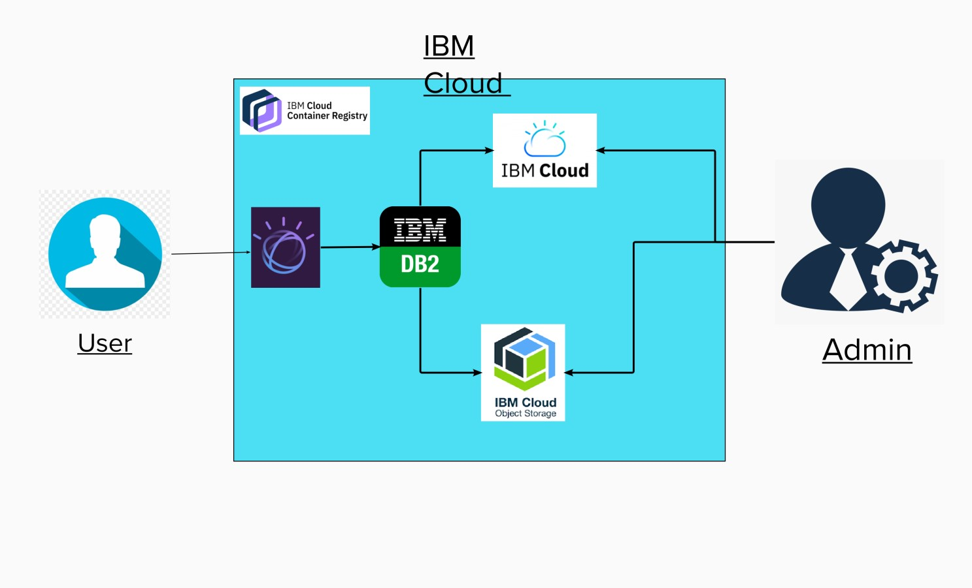  
**Technical Architecture:**

Table-1: Components & Technologies:

|  |  |  |  |
| --- | --- | --- | --- |
| S. No | Component | Description | Technology |
| 1. | Website | Customer can proceed the website and interact with the chatbot to get the desire product | HTML, CSS, JavaScript, Watson chatbot |
| 2. | Docker | Service for storing the private container images | Container |
| 3. | IBM Object Storage | Bucket are used to upload the images and files | Bucket |
| 4. | Kubernetes | Manage the complete process in the stable state  If any software crash it automatically restart the work | Kubernetes |
| 5. | DB2 | Data types are String, Numeric, Date, time, and timestamp distinct types.  Act_ sortmem_ limit, auto_ del_ rec _ obj, auto_ maint Configuration . | MySQL |
| 6. | Cloud DB2 | A fully managed cloud database with AI capabilities that keep our website running 24*7. | IBM DB2 |
| 7. | Watson chatbot | Customers can search the product easily by humanlike interaction with bot. | IBM Watson Assistant |
| 8. | Infrastructure (Server / Cloud) | Application Deployment on Local System / Cloud  Local Server Configuration: Anaconda  Cloud Sever Configuration: IBM cloud | Local, Cloud Foundry, Kubernetes, etc. |

Table-2: Application Characteristics:

|  |  |  |  |
| --- | --- | --- | --- |
| S. No | Characteristics | Description | Technology |
| 1. | Open-Source Frameworks | Cloud Stack, Eucalyptus.  Open Nebula, App Scale, Docker. | Docker |
| 2. | Security Implementations | Authentication and password management Accountability to authorize and monitor the use anonymous accounts and to remove | Encryptions, Secured Authorization. |
| 3. | Scalable Architecture | To expand our server capacity, memory, or disc space so that more people may transact on your website.  Chat bots to provide scalable customer support. | DB2, Watson chatbot |
| 4. | Availability | The administrator needs to look up the stock availability in the database | Docker |
| 5. | Performance | Speed up the webpage  Site optimization based on data analysis. | Kubernetes |